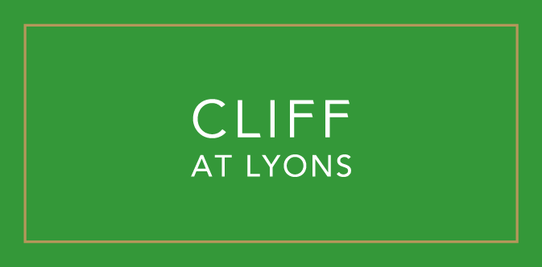

The Orangery
Lunch Menu

Soup of the Day €8.50
Homemade Guinness Bread, Glenilen Farm Butter
(1,5,7)

Eggs Norwegian €13.50
Two Poached Eggs, Terry Butterly’s Smoked Salmon, Avocado, Hollandaise Sauce
(2,4,7,14)

Classic Caesar Salad €11
Gem Lettuce, Smoked Bacon Lardons, Aged Parmesan, White Anchovies, Croutons, Coddled Eggs
add chicken €5 supplement
(1,2,4,5,7)

Garden Beetroot Salad €11
Ardsallagh Goats Cheese, Beetroots, Hazelnuts, Orange, Mixed Leaf
(4,9,10)

Orangery Seafood Skillet €26
Cod, Salmon, Cockles, Mussels, White Wine, Crème Fraiche, Lemon, Parsley, Tomato, Sourdough Toast
(2,5,7,8,14)

Fish and Chips €23
Battered Haddock, Chunky Chips, Marrowfat Peas, Tartare Sauce, Lemon
(2,4,5,14)

10oz John Stone Striploin €30
Chunky Chips, Fried Hen Egg, Three Pepper Sauce
(2,4,5,7)

Tagliatelle €22
Seasonal Mushrooms, Aged Parmesan, Garden Herbs, Pine Kernals
(5,7,10)

Red Pepper Risotto €22
Braised Violet Artichokes, Toonsbridge Mozzarella,
(7)

Sides €4.75
Garden Salad French Fries Mashed Potatoes Cauliflower Gratin Green Beans
(9) (5,7) (5,7) (5,7)

Desserts

Cliff Ice Cream €9.00
Coconut Ice Cream, Pineapple Sorbet, Rum
(10)

Raspberry Bombe €11.00
Raspberry Mousse, Passionfruit Sorbet, Shortbread
(4,5,7)

Organic Chocolate Bar €11.50
68 % Cliff 10 Chocolate, Peanut Mousse, Dulcey Ice-Cream, Peanut Brittle
(4,7,10)

Garden Apples €10.00
Caramel Sauce, Blackberry Ice Cream, Garden Rhubarb
(4,5,7,14)

Tea
Irish Breakfast Tea €3.25, Earl Grey €3.50

Herbal Tea
Green Gunpowder, Green Jasmine, Peppermint Leaves, Rooibos, Camomile,
Ginger & Lemon, Redberry Fruit Blend, Passionfruit & Orange €3.50
Coffee
Americano €3.75, Espresso €3.35, Latte €3.90, Cappuccino €3.90, Flat White €3.90
All coffees are available as a decaf option

Hot Beverages
Hot Chocolate €4.25

Please note that all of our dishes are prepared-to-order and may contain allergens.
Our kitchen operation involves shared cooking and preparation areas
therefore, we cannot guarantee that any menu item can be completely free of allergens.
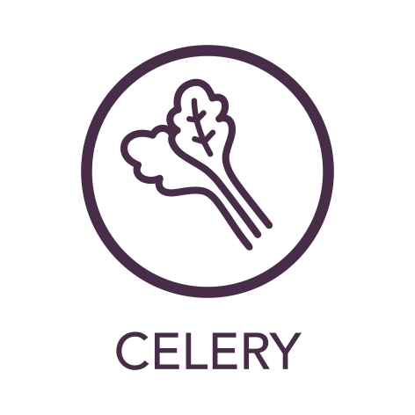1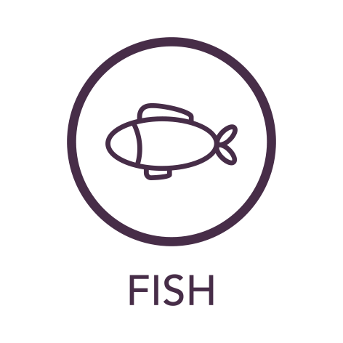2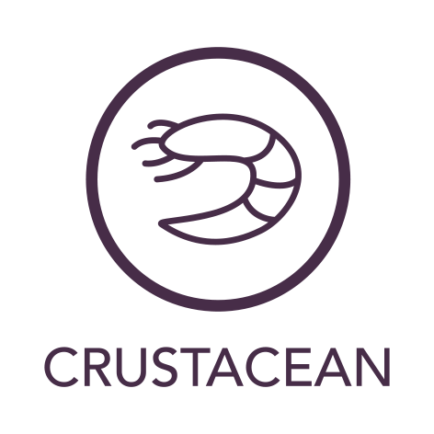3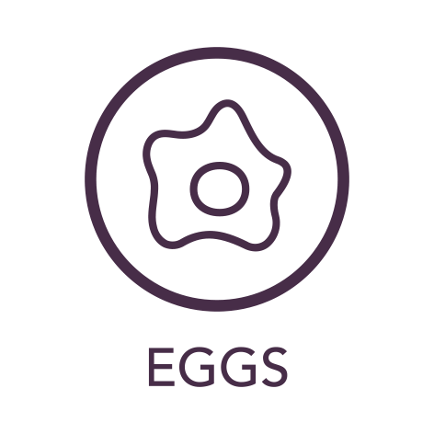4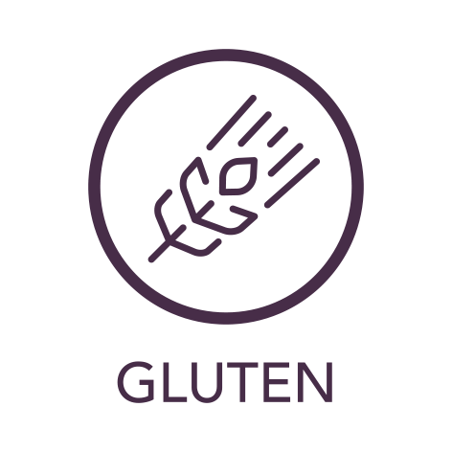5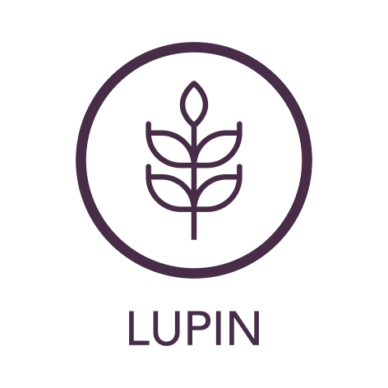6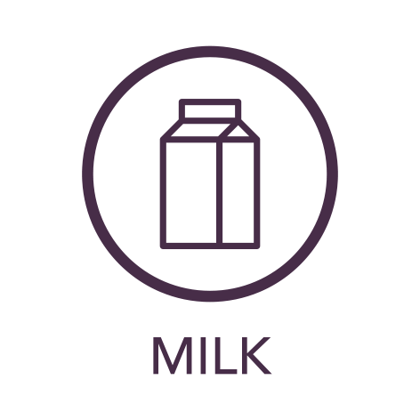7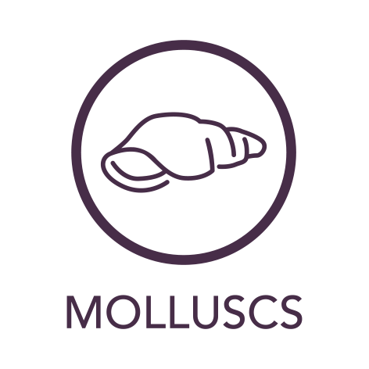8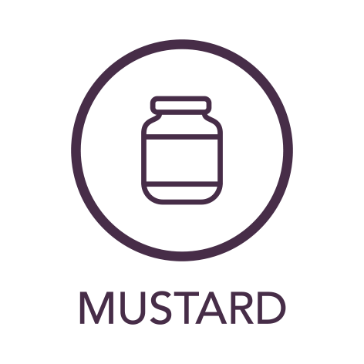9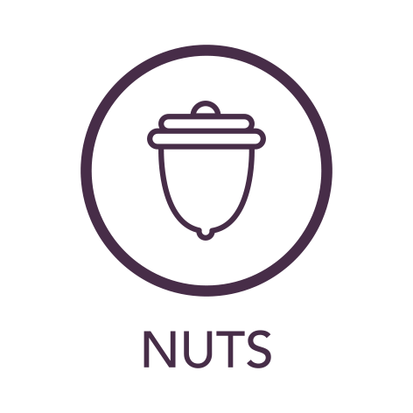10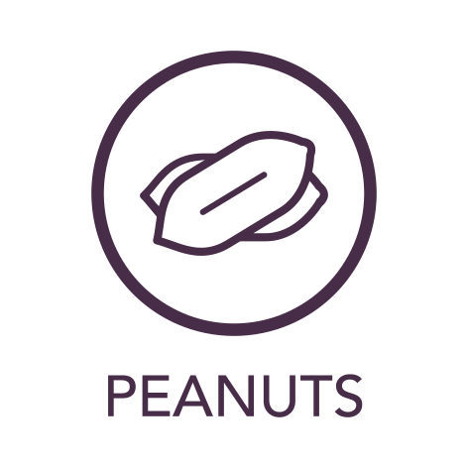11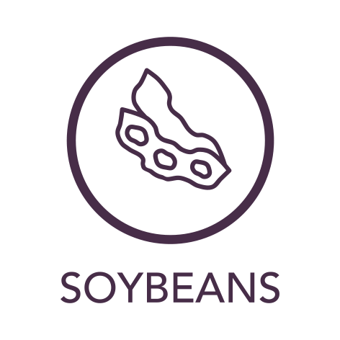12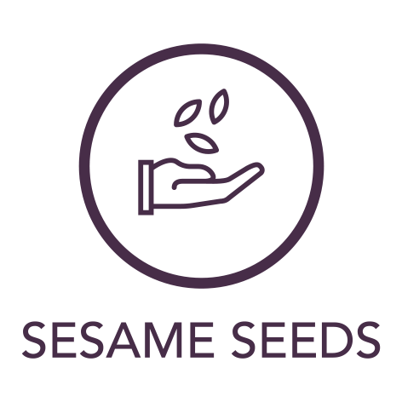13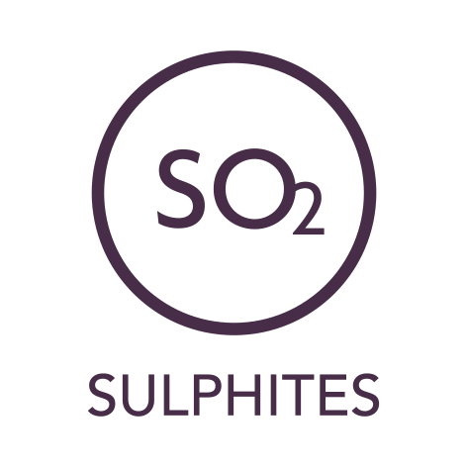14

